WELCOME

Ang Pagbabasa ng Guide na ito ay mahalaga sa Lahat ng Retailer.
Kung Maari ay pakibasa at pakiunawa.

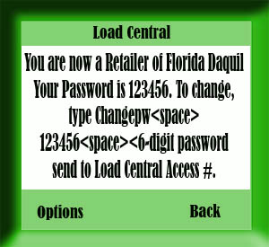

Dalawa ang Password ng Retailer.

Una ay ang
First Level Password (FL) or SMS Password

- Tinatawag din itong SMS or Cellphone Password
- Ito ay ginagamit sa mga transactions using Cellphone.

Default Password is 123456

Para Palitan ang FL/SMS Password
Gamit ang sariling Cellphone

TEXT
CHANGEPW<space>OLD PASSWORD<space>NEW PASSWORD and send to
Load Central Access Number.

Example:
CHANGEPW 123456 987654

and send to Load Central Access Number

REMINDER:
Password must be alphanumeric and 6 characters in length only.

May matatanggap ka pong Confirmation na Successful ang Change Password mo
kung tama ang ginawa mo.

Load CENTRAL ACCESS NUMBERS

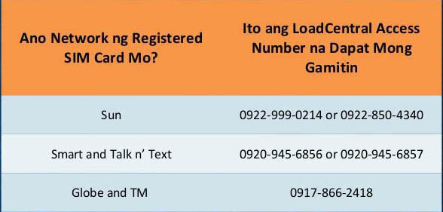

Tandaan:

Free of Charge po ang lahat ng transaction using your cellphone kung nakaregister ka sa kahit anong unli promo ng network na gamit mo.. Kung hindi Standard Rate charges.

Maari mong gamitin ang lahat ng Access Numbers, mas maganda nga lamang na duon mo I send sa kaparehas ng network mo para maging free of charge kung naka unli ka.

Second Level Password (SL) or Webtool Password –
for logging in to the webtool and
for transactions using the internet.

- Tinatawag din itong Webtool Password
- Ginagamit ito sa pag Log in sa inyong Retailer Webtool.
https://loadcentral.net/

Ang inyong username ay ang inyong Registered Retailer Number
Palitan po lang ng 63 ang Prefix na 0

Halimbawa
Registered Number
09181234567
Ang Username mo ay
639181234567

Default Password is 123456

Tandaan!
Dapat munang mag Send ng TEXTS to UNLOCK your webtool.
To Unlock your webtool

TEXTS
UNLOCK<space>FL/SMS password and send to Access Numbers
Halimbawa:
UNLOCK 123456
Send to Access Numbers

Kapag Nagkaroon ng IP ERROR I set ang inyong IP address by texting

SETIP<space>Your SMS Password<space>*.*.*.*
Then Send to Access Numbers

As is.. gayahing mabuti.. 4 na asterisks and 3 periods

EXAMPLE
SETIP 654321 *.*.*.*

TANDAAN!
Dapat ay hindi magkaparehas ang inyong FL/SMS PASSWORD AT WEBTOOL PASSWORD

Pagkatapos gawin ang mga STEPS na ito.. Ay maari na po kayong bumili ng
LOADWALLET sa LOAD CENTRAL

LOADWALLET REPLENISHMENT

Ang Minimum na Loadwallet na isinasuggests kong ipurchase nyo is Php 500

These are the currently accepted modes of payment for Load Wallet Replenishment
ACCOUNT NAME (Applies to All):
UNIWIZ TRADE SALES, INC.
BDO: 2530013337
BPI: 9661-014633
Metrobank: 055-3-0555-017640
Smart Money: 5577-5113-2164-6117
Bank deposits are to be made on Mondays to Fridays at 9am to 4:30pm only,
and on Saturdays at 9am to 11:30am only.
There are no Loadwallet Replenishments on Sunday in Bank Deposits But
Smart Money Fund Transfer is open 24/7 even on holidays!

Follow The Texts format on how to Verify your Load Wallet Deposits.
Refer to the Example Images.

FREE OF CHARGE PO Ang Lahat ng Transaction sa bangko..

FOR BDO
2530013337

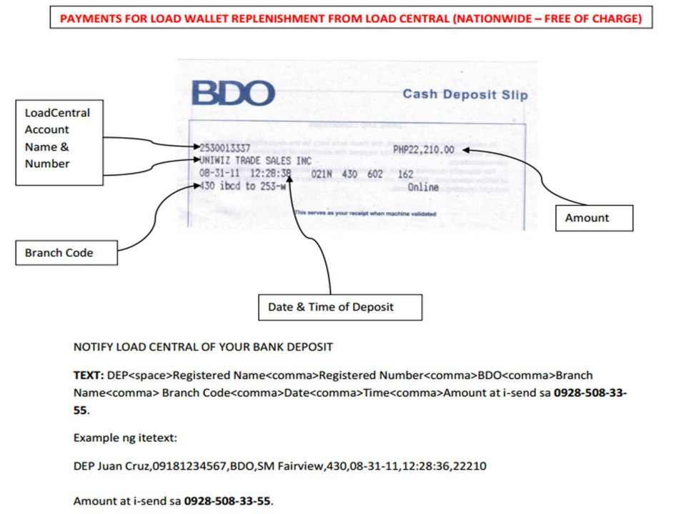

BPI
9661-014633
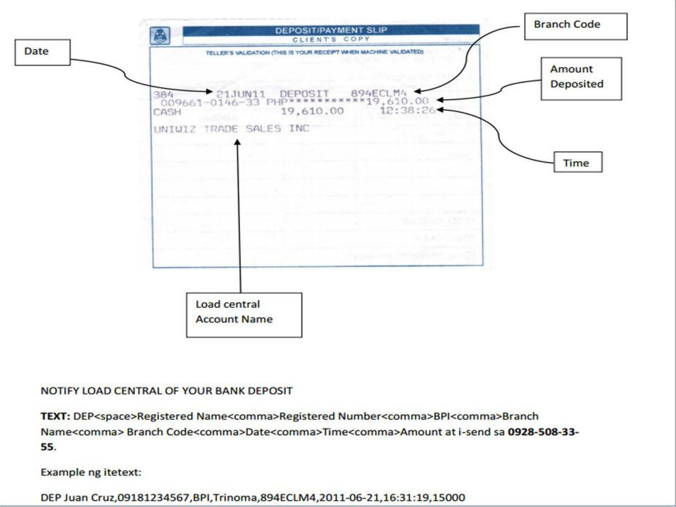

Metrobank
055-3-0555-017640
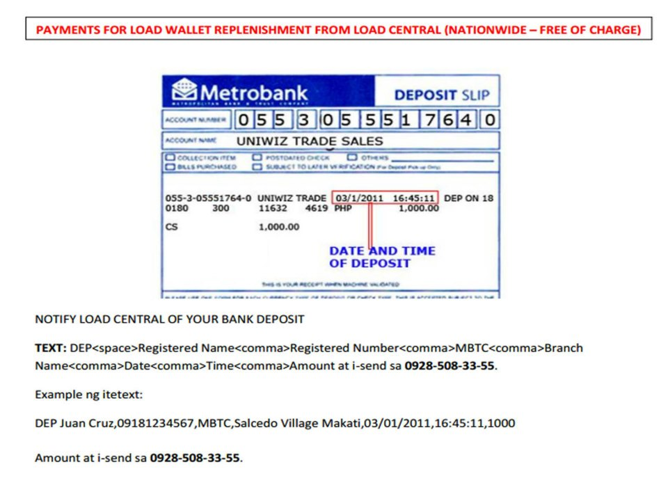

Smart Money
5577-5113-2164-6117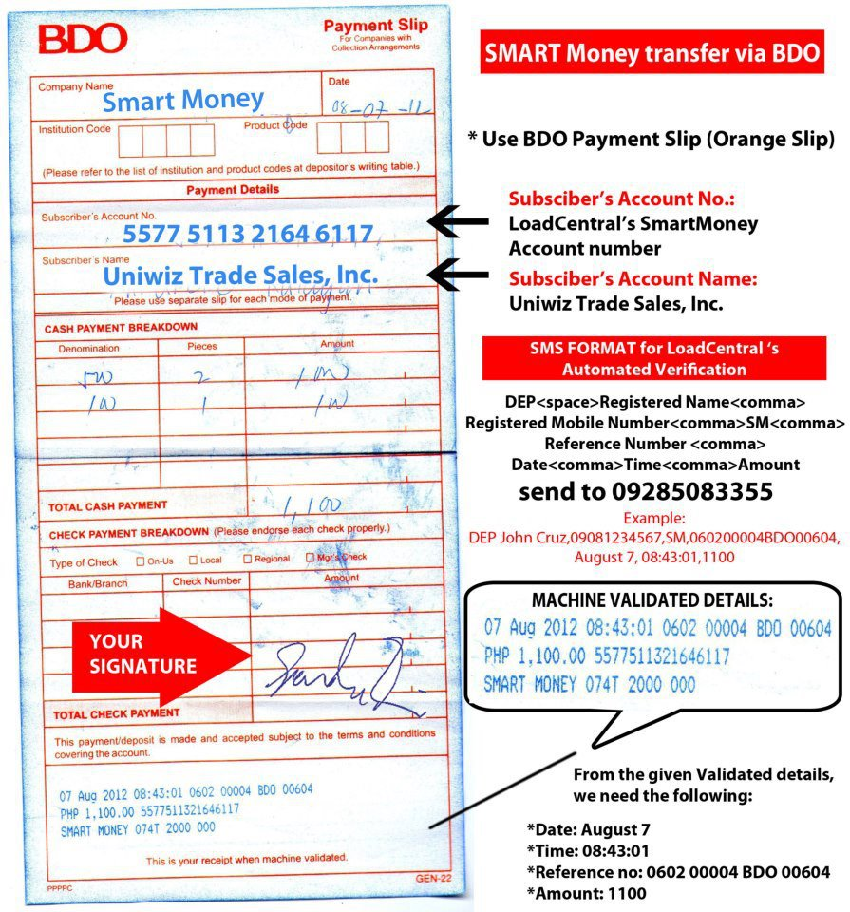

Maximum of 2 hours lamang po ang pagpapaverify ng inyong Loadwallet.
Dapat ay magrereply Ang Load Central sa inyo kung tama ang inyong texts at format na within the day marerecieved nyo ang inyong loadwallet.

Maari pong I follow up ang inyong Load Wallet Replenishment
I chat lang ang Load Central.

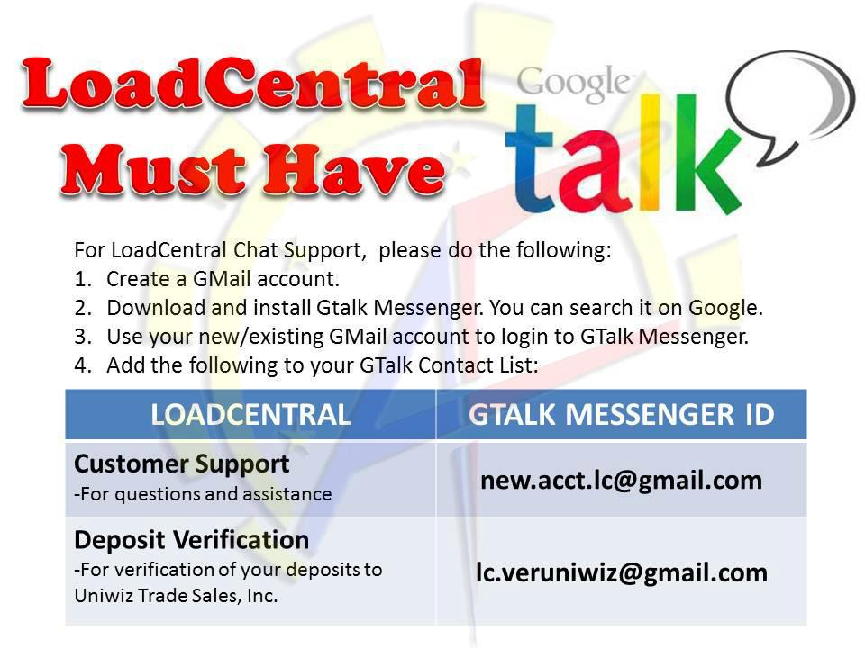

Mga kadalasang Problema.. Please Refer to this Images.

Common SMS COMMANDS

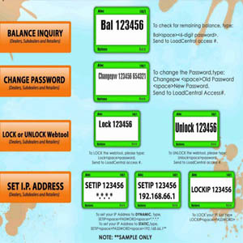

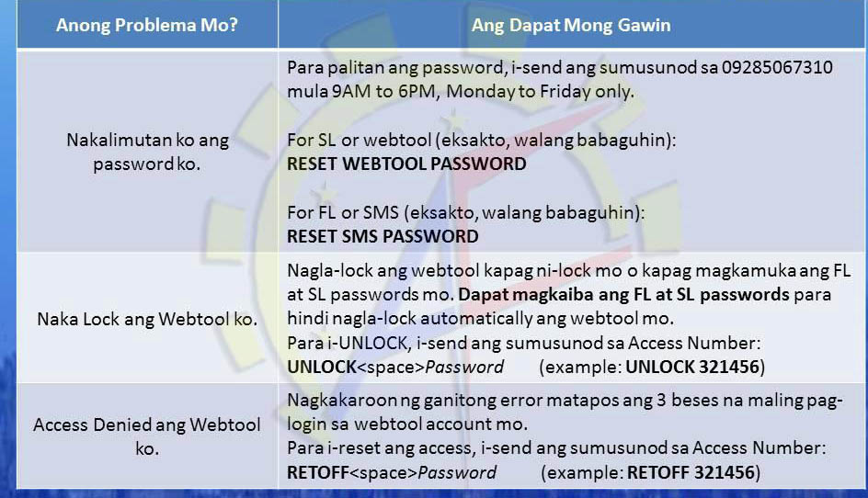

If May Problems Please FEEL FREE TO TEXTS ME..
SMART- 0910-226-65-65
Sun- 0943-325-51-49
GLOBE- 0906-785-82-00

Thanks And God Bless..

